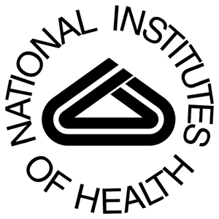
Chemistry-Biochemistry-Biology Interface (CBBI) Program
Training at the Interface of Chemistry and Biology-Related Disciplines

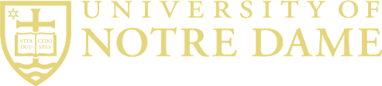

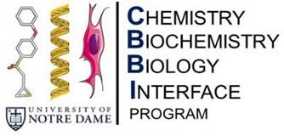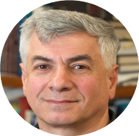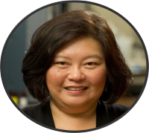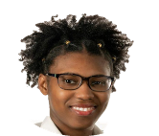CBBI Alumni
CBBI Program
- NIH-funded since 2007
- 84 graduate students trained
- 57 (68%) graduated with Ph.D. degrees in 5.14 years
- Trainees have 362 publications, 159 as first author
- 28 faculty, 4 departments at ND

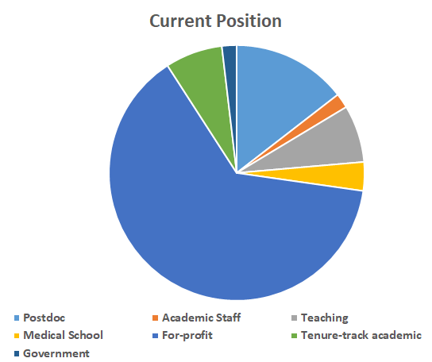
Mayland Chang Program Director mchang@nd.edu
Shahriar Mobashery Program Co-Director mobashery@nd.edu
Current CBBI Fellows
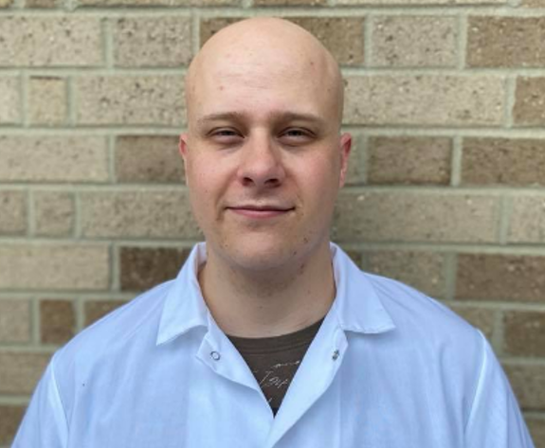
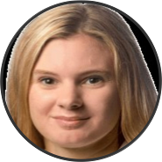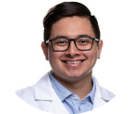Renee Bouley, 2012-2015
Chemistry, Mobashery and Chang Labs, Currently Assistant Professor, Ohio State University, Marion, OH
- AHA Postdoctoral Fellowship 2018-2019
- Shaheen Award 2017
- ACS Scarborough Award 2017
Hannah Corman
Biology
McDowell Lab
IN CTSI Fellowship2019
Kurtis Breger
Biochemistry
Brown Lab
Verodia Charlestin
Biochemistry
Littlepage Lab
Luis Avila Biochemistry Mobashery Lab

- Dow Chemical Award 2016
- NIH F31 Fellowship 2015-2017
- 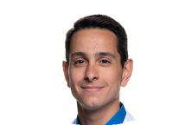ACS MEDI Fellowship 2013
- 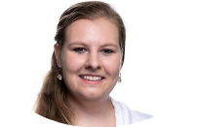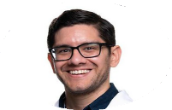Training publications: 7 (2 as first author)
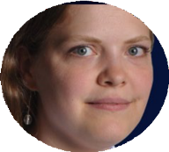Esther Braselmann, 2010-2013 Biochemistry, Clark Lab Currently Assistant Professor, Georgetown University, Washington,DC
Esther Braselmann, 2010-2013
Biochemistry, Clark Lab
Currently Assistant Professor, Georgetown University, Washington, D.C.
- NIH K99 Award 2018
- Training Publications: 7 (3 as first author)
- NIH K99 Award 2018
- Training publications: 7 (3 as first author)
Elizabeth Harper
Biochemistry
Stack Lab
NIH F99 2020
Brad Keegan
Biochemistry
Blagg Lab
Charlotte Kunkler
Biochemistry
Brown Lab
NIHF31 Award 2020

Homero Dominguez
Chemistry
Mobashery Lab

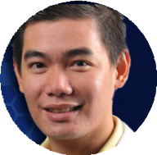Major Gooyit, 2009-2012
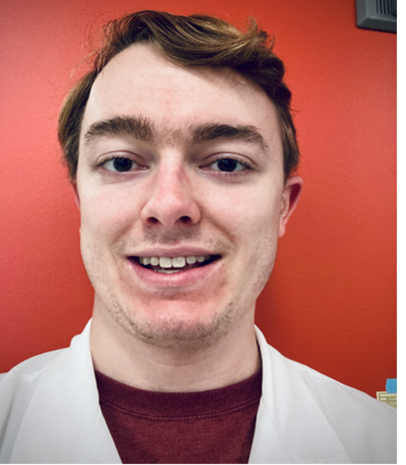
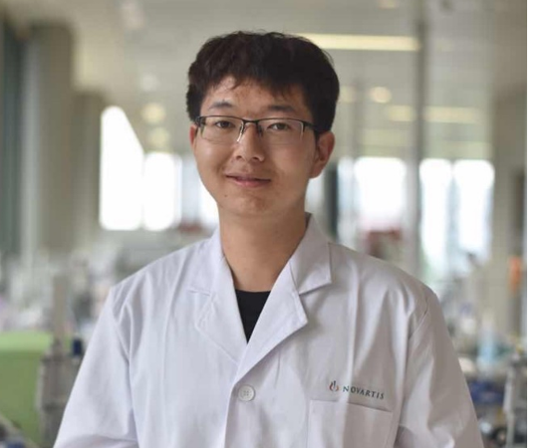
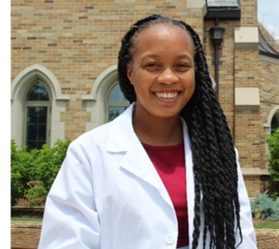
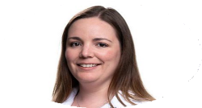Chemistry, Mobashery and Chang Labs
Currently Senior Scientist II, Abbvie,
North Chicago, IL
- Shaheen Award 2013
- Baxter Young Investigator Award 2012
- Training publications: 12 (6 as first author)
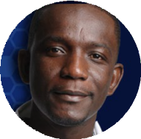
Guoqiang Liu
Biology
Lu Lab
Taylor Lundgren
Biochemistry
M. Champion & Clark Lab
Maria Cristina Miranda Vergara
Biochemistry
Littlepage Lab
AAUW Award 2019
Janeala Morsby
Biochemistry
B. Smith Lab
Francis Insaidoo, 2007-2009 Biochemistry, Baker Lab
Currently Associate Principal Scientist, Merck, Inc. Newark, NJ
  - Training publications: 6 (2 as first author)
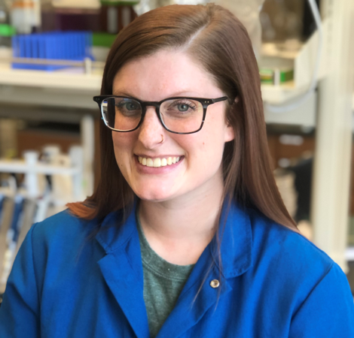
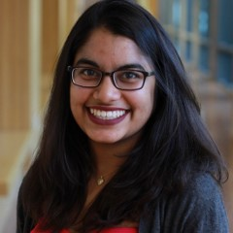
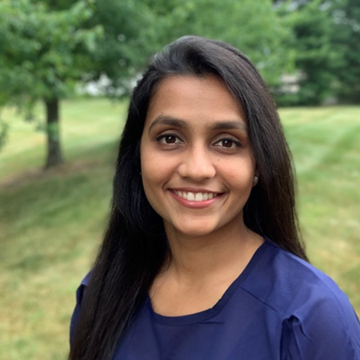
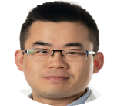Lindsay Sweet, 2007-2008 Biological Sciences, Schorey Lab Currently Field Medical Director, Pfizer, Boulder, CO
- 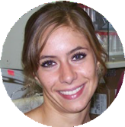Training publications: 5 (3 as fir author)
Lindsay Sweet, 2007-2008 Biological Sciences,
Schorey Lab
Currently Field Medical Director,
Pfizer, Boulder, CO
- Training Publications: 5 (3 as first author)

Ansley Nemeth
Biochemistry
Melander Lab
ACS MEDI Fellowship2021
Himani Patel
Biochemistry
Helquist & Wiest
Naviya Schuster- Little
Chemistry
Whelan Lab
Yuanyuan Qian
Chemistry
Mobashery & Chang Labs

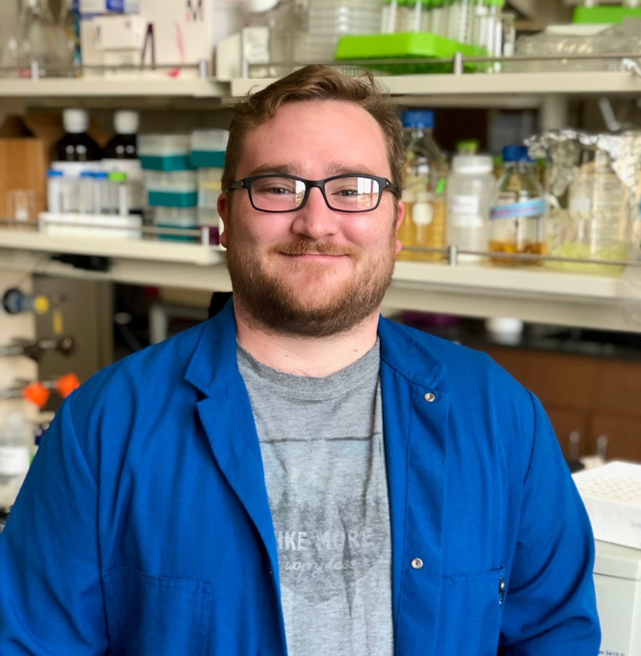
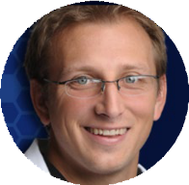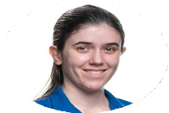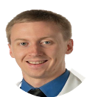Tim Wencewicz, 2007-2010 Chemistry, Miller Lab
Currently Associate Professor, Washington
University, St. Louis, MO
  - Sloan Research Fellowship 2018
  - Cotrell Scholar Award 2017
  - NSF Career Award 2017
  - ACS Infectious Disease Young Investigator
Robert Stanley
Biology
Romero-Severson Lab
Kathryn Trentadue Chemistry
Taylor Lab
Alexander Weig
Chemistry
Melander Lab
Award 2016
  - Shaheen Award 2012
  - Training publications: 8 (5 as first author)

