Chemistry-Biochemistry-Biology Interface Annual Symposium
May 24-25, 2021

Final Program

Monday, May 24th

Zoom link:
https://notredame.zoom.us/j/93142086265?pwd=RXUzUXk2UzVVUGhXWUlMdS9ZQVpOdz09

9:00 – 9:05 AM Welcome
9:05 – 10:15 AM Session I
Chair: Elizabeth Harper
9:05 – 9:25 AM Janeala Morsby
Department of Chemistry and Biochemistry
NEW ENZYME ASSAYS USING SURFACE ENHANCED RESONANCE SPECTROSCOPY.

9:25 – 9:45 AM Heather Shepherd
Department of Chemistry and Biochemistry
Development of a Yeast-based Assay for Bioavailable Phosphorus

9:45 – 10:05 AM Jaeho Shin
Department of Chemical and Biomolecular Engineering
Inhibition of Aggressive GRP78+ Breast Cancer Metastasis Using Rationally Designed Peptide-targeted Liposomal Nanoparticles
10:05 – 10:15 AM Break
10:15 – 11:15 AM Session II
Chair: Janeala Morsby
10:15 – 10:35 AM Elizabeth Harper
Department of Chemistry and Biochemistry
Age-related Changes in the Microenvironment Enhance Ovarian Cancer Metastasis

10:35 – 10:55 AM Guoqiang Liu
Department of Biological Sciences
The Differential Targeting of Gr-MDSCs, T Cells and Prostate Cancer Cells by Dactolisib and Dasatinib

10:55 – 11:15 AM Parinda Tennakoon
Department of Chemistry and Biochemistry
Regulation of Endocrine Therapy Resistance in Breast Cancer by ZNF217
11:15 – 11:25 PM Break
11:25 – 12:25 AM Session III
Chair: Luis Avila
11:25 – 11:45 AM Ansley Nemeth
Department of Chemistry and Biochemistry
Identification of Adjuvants that Potentiate Macrolide Activity Against Gram -negative Bacteria

11:45 – 12:05 PM Yuanyuan Qian
Department of Chemistry and Biochemistry
Structure−Activity Relationship for the Oxadiazole Class of Antibacterial Against Clostridiodes difficile and Target Profiling

12:05 – 12:25 PM Naviya Schuster-Little
Department of Chemistry and Biochemistry
Afffinity-free Enrichment and Mass-spectrometry Characterization of CA125 (MU16) from Ovarian Cancer Patient Ascites
12:30 – Boxed Lunch - pick up lunch box 1st floor McCourtney café - Charlotte Kunkler

4:30 – 5:15 PM Pick up food and drinks 1st floor McCourtney café - Verodia Charlestin

5:30 – 7:00 PM Poster Session. Gather town link: https://gather.town/i/uTwBHeYz PASSWORD: CBBI2021

Tuesday, May 25th

Zoom link:
https://notredame.zoom.us/j/91375615754?pwd=eGcvdmtKb2xtT3JJQ3JiTXR1dloxQT09

12:50 – 1:00 PM Awards
1:00 – 2:00 PM Plenary Session
Chair: Bradley Keegan
Prof. Daniel Herschlag
Stanford University
Bringing enzymology into the genomic era

CBBI SYMPOSIUM KEYNOTE SPEAKER
PROFESSOR DANIEL HERSCHLAG
DEPARTMENT OF BIOCHEMISTRY, STANFORD UNIVERSITY

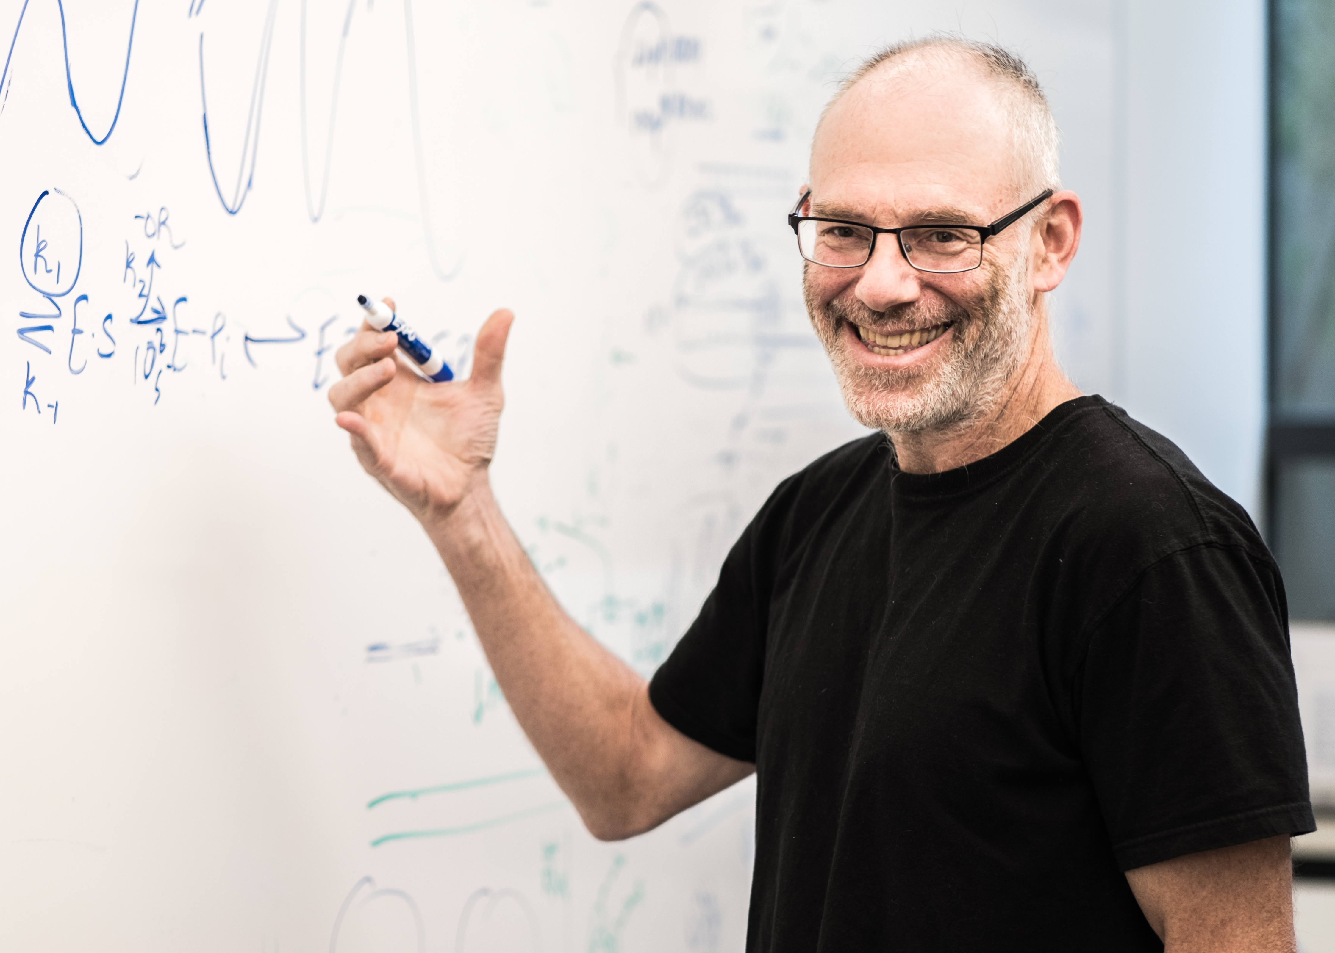

The overarching goal of my research program has been to understand the chemical and physical principles that underlie biological processes as these principles are needed to understand how biology works and how it evolved; the fundamental physical and chemical properties of biomolecules enable and constrain biological function and evolution. This understanding will ultimately permit precise and impactful molecular manipulation for engineering and therapy. My research in mechanism began as a graduate student, where I studied principles of phosphoryl transfer. My research in RNA began as a postdoc, where I applied and developed rigorous tools of mechanistic enzymology to study RNA catalysis and developed catalytic assays to follow RNA folding.
My lab has been highly interdisciplinary and collaborative, leading to important discoveries and new directions in enzyme and RNA research, including the RNA Chaperone hypothesis; the evolutionary and mechanistic concept of Catalytic Promiscuity; pioneering genomic studies with Pat Brown that revealed global regulation and organization of gene expression by RNA binding proteins; the first FRET-based single molecule folding experiments with Steve Chu; with Joe Piccirilli, quantitative thermodynamic fingerprint analysis to dissect specific metal ion interactions within the sea of RNA-associated metal ions; pioneering SAXS applications with Seb Doniach and Pehr Harbury to RNA folding and conformational ensembles; dissection of the interrelationship between hydrogen bond structure, their environment, and their energetics; and identification of new catalytic mechanisms such as ground state electrostatic destabilization and aromatic-anion interactions to position enzymatic general bases. I am passionate about training the next generation of scientists and science-based thinkers, and I have created innovative courses and training programs for graduate students, postdocs, and to further diversity and the success of trainees from underrepresented and underprivileged backgrounds while serving as Senior Associate Dean of graduate students and postdocs in the Stanford School of Medicine. Over the past 28 years I have mentored students from diverse backgrounds, including 32 PhD students, 35 postdocs, undergraduates, and high school students in my lab, as well as dozens of additional graduate students in my capacities as Senior Associate Dean and Graduate Advisor. I meet with my trainees weekly, complete annual IDP meetings, and work with them closely to ensure not only timely PhD completion, but development of the conceptual understanding, experimental prowess, written communication skills, and sense of community responsibility needed to become transformative members of the scientific community. Students and postdocs trained in my lab have been highly successful in academic and other leadership positions, with former students and postdocs on the faculty at CalTech, UCSF, Scripps, and Stanford, among other institutions. I emphasize for each trainee that they should explore and pursue their career of choice, without concern for what others around them view as more or less prestigious options. I look forward to the continued opportunity to address important and exciting biological problems, to participate in and contribute to multidisciplinary research, and to help trainees develop as scientists, citizens, and advocates for reason-based discussions, diversity, and inclusion.

ORGANIZING COMMITTEE

LUIS AVILA
MAYLAND CHANG
VERODIA CHARLESTIN
HANNAH CORMAN
ELIZABRETH HARPER
BRADLEY KEEGAN
CHARLOTTE KUNKLER
JANEALA MORSBY
YUANYUAN QIAN

AWARDS COMMITTEE

JESSICA BROWN
JED FISHER
SIYUAN ZHANG

POSTERS

- ELUCIDATING THE INERACTOME OF THE LYTIC TRANSGLYCOSYLASE RLPA OF PSEUDOMONAS
LUIS FELIPE AVILA, STEFANIA DE BENEDITTI, RHONA FELTZER, MATTHEW CHAMPION, AND SHAHRIAR MOBASHERY
Department of Chemistry and Biochemistry, University of Notre Dame, Notre Dame, Indiana, 46556
- ELUCIDATING THE KINETIC MECHANISMS OF HUMAN METTL16

KURTIS BREGER, NATHAN J. O’LEARY, NOAH A. SPRINGER, AGNIESZKA RUSZKOWSKA, AND JESSICA A. BROWN

Department of Chemistry and Biochemistry, University of Notre Dame, Notre Dame, Indiana, 46556
- CLIPR-76, A NOVEL CLIPR PROTEIN LINKING MEMBRANES AND MICROTUBULES
JILL VOREIS, ANNAMARIE BRYANT, GERGANA UGRINOVA, CLAIRE WHALEN, AND HOLLY GOODSON
Department of Chemistry and Biochemistry, University of Notre Dame, Notre Dame, Indiana, 46556
- NOVEL METABOLIC NETWORK IDENTIFY KEY METABOLIC HUBS OF BREAST CANCER PROGRESSION: THE EFFECTO AQUAPORIN-7 ON BREAST CANCER PROGRESSION
CHEN DAI ^{1,2}, VERODIA CHARLESTIN^{1,2}, MARIA CRISTINA MIRANDA VERGARA^{1,2}, BETH A. FACCHINE^{1,2}, JUNMIN WU^{1,2}, JENNIFER ARCEO^{1,2}, NORMAN J. DOVICHI^{1,2}, JUN LI^{2,3}, AND LAURIE E. LITTLEPAGE^{1,2}
Department of Chemistry and Biochemistry¹, University of Notre Dame, Notre
Dame, IN 46556; Harper Cancer Research Institute², South Bend, IN 46617;
Department of Applied and Computational Mathematics and Statistics³,University of Notre Dame, Notre Dame, IN 46556
- INVESTIGATION OF A SERIES OF 1,4-DIARYL-PYRAZOLO-PYRIDIONES AS ANTI-LEISHMANIAL AGENTS
HANNAH N. CORMAN¹, DOUGLAS A. SHOUE¹, BRUCE J. MELANCON²*, MARY ANN MCDOWELL¹
Eck Institute for Global Health, Biological Sciences¹, University of Notre Dame, Notre Dame, IN 46556; Warren Center for Drug Discovery and Development², University of Notre Dame, Notre Dame, IN46556; Vanderbilt Center for Neuroscience Drug Discovery*, Vanderbilt University, Nashville, TN37203
- PENICILLIN-BINDING PROTEIN 2X(PBP2X) AS A TARGET OF ALLOSTERIC INHIBITION BY ANTIBIOTICS
HOMERO I. DOMNGUEZ, NEHA RANA, MOHINI-MOHAN KONAI,
JESHINA JANARDHANAN, KIRAN MAHASENAN, AND SHAHRIAR MOBASHERY

Department of Chemistry and Biochemistry, University of Notre Dame, Notre Dame, Indiana, 46556
- STRUCTURE OF F1FO ATP SYNTHASE WITH CRUENTAREN A

POSTERS

XIAOZHENG DOU¹, HUI GUO², BHARGAV A. PATEL¹, TERIN D’AMICO¹,

JOHN RUBINSTEIN², AND BRIAN S. J. BLAGG¹

Department of Chemistry and Biochemistry¹, University of Notre Dame, Notre Dame, Indiana, 46556; Department of Medical Biophysics², The University of Toronto, Ontario, Canada M5S 1A4
- METABOLISM OF THE SELECTIVE MATRIX METALLOPROTEINASE-9 INHIBITOR (R) –ND-336.

CHARLES EDWIN RAJA GABRIEL, TRUNG T. NGUYEN, EMANUELE MARCO GARGANO, JED F. FISHER, MAYLAND CHANG, AND SHAHRIAR MOBASHERY

Department of Chemistry and Biochemistry, University of Notre Dame, Notre Dame, Indiana, 46556
- CLONING UNNATURAL AMINO ACID SYSTEMS IN PSEUDOMONAS: RLPA, A CASE-STUDY

RHONA FELTZER, MARK E. HORSMAN, LUIS AVILA, SARA COLE, AND SHAHRIAR MOBASHERY

Department of Chemistry and Biochemistry, University of Notre Dame, Notre Dame, Indiana, 46556; Optical Microscopy Core, University of Notre Dame, Notre Dame, IN 46556
- THE EFFECT OF PHOSPHORYLATION OF THE LIPOPROTEINS IN S. AUREUS

HIDEKAZU HOSHINO, CHOON KIM, AND SHAHRIAR MOBASHERY

Department of Chemistry and Biochemistry, University of Notre Dame, Notre Dame, Indiana, 46556
- USING THE TUBULIN-LIKE PHAGE PROTEIN PHUZ TO STUDY THE FUNDAMENTAL PROPERITIES OF BIOLOGICAL ENERGY UTILIZING POLYMERS

YAOBING HUANG AND HOLLY V. GOODSON

Department of Chemistry and Biochemistry, University of Notre Dame, Notre Dame, Indiana, 46556
- INHIBIT CANCER PROGRESSION BY DEVELOPING LIPID NANOPARTICLES CAPABLE OF DELIVERING THERAPEUTIC PAYLOADS SELECTIVELY INTO TUMOR ASSOCIATED MACROPHAGES (TAMS) TO ACTIVATE ANTI-CANCER EFFECTOR FUNCTIONS

SABRINA KHAN, FRANKLIN MEJIA, AND BASAR BILGICER

Department of Chemical and Biomolecular Engineering, Department of Chemistry and Biochemistry, University of Notre Dame, 46556
- PRODUCTION OF PROTEINS OF SARS-COV-2 PROTEOME FOR DRUG DISCOVERY

CHOON KIM, KIRAN V. MAHASENAN, ATUL BHARDWAJ, OLAF WIEST, MAYLAND CHANG, AND SHAHRIAR MOBASHERY

Department of Chemistry and Biochemistry, University of Notre Dame, Notre Dame, Indiana, 46556
- THE CXCL5/CXCR2 AXIS IS SUFFICIENT TO PROMOTE BREAST CANCER COLONIZATION DURING BONE METASTASIS

POSTERS

COURTNEY KING^{1,2}, RICARDO ROMERO-MORENO^{1.2}, KIMBERLY J. CURTIS^{1,3}, THOMAS R. COUGHLIN^{1,3}, MARIA CRISTINA MIRANDA VERGARA^{1,2}, SHOURIK DUTTA^{1,2}, AISHWARYA NATARAJAN^{1,2}, BETH A. FACCHINE^{1,2}, KRISTEN JACKSON^{1,3}, JUN LI^{1,4}, WILLIAM KALINEY¹,GLEN L. NIEBUR^{1,2}, AND LAURIE E.

LITTLEPAGE^{1,2}
Harper Cancer Research Institute¹, South Bend, IN 46617; Department of
Chemistry and Biochemistry², University of Notre Dame, Notre Dame, IN 46556;
Tissue Mechanics Laboratory³, Department of Aerospace and Mechanical
Engineering, Bioengineering Graduate Program, University of Notre Dame,
Notre Dame, IN 46556; Department of Applied and Computational Mathematics
and Statistics⁴, University of Notre Dame, Notre Dame, IN 46556
- A SINGLE MODIFIED NUCLEOSIDE DESTABILIZES AN RNA•DNA–DNA TRIPLE HELIX

CHARLOTTE N. KUNKLER, GRACE E. SCHIEFELBEIN, NATHAN J. O’LEARY, AND JESSICA A. BROWN

Department of Chemistry and Biochemistry, University of Notre Dame, Notre Dame, Indiana, 46556
- CHARACTERIZATION OF KANAMYCIN INDUCED TRANSLATIONAL SUBSTITUTIONS

TAYLOR LUNDGREN, MATTHEW CHAMPION, AND PATRICIA CLARK

Department of Chemistry and Biochemistry, University of Notre Dame, Notre Dame, Indiana, 46556
- MMP3 DEFICIENCY IN CARCINOMA-ASSOCIATED FIBROBLASTS INHIBITS PRIMARY TUMOR GROWTH

MARIA CRISTINA MIRANDA VERGARA, AISHWARYA NATARANJAN, WILLIAM KALINEY, JUMIN WU, AND LAURIE E. LITTLEPAGE
Department of Chemistry and Biochemistry, University of Notre Dame, Notre Dame, IN 46556; Harper Cancer Research Institute, South Bend, IN, 46617
- DESIGN AND SYNTHESIS OF BlAR1 INHIBITORS IN METHICILLIN-RESISTANT STAPHYLCOCCUS AUREUS
VAN NGUYEN, ANDREAS BASTIAN, CHARLES GABRIEL, CHOON KIM AND SHAHRIAR MOBASHERY

Department of Chemistry and Biochemistry, University of Notre Dame, Notre Dame, Indiana, 46556
- COMPUTATIONAL STUDY OF PSEUDOMONAS MEVALONII HMG-COA REDUCTASE CATALYZED MEVALDYL-COA DECOMPOSITION

HIMANI N. PATEL, TAYLOR R. QUINN, BRANDON HAINES, OLAF WIEST, PAUL HELQUIST

Department of Chemistry and Biochemistry, University of Notre Dame, Notre Dame, Indiana, 46556; Department of Chemistry and Biochemistry, University of Notre Dame, Notre Dame, Indiana, 46556

POSTERS

- SYNTHETIC PEPTIDE LIBRARIES DESIGNED FROM THE BIOACTIVE DOMAIN OF AS-48-BACTERIOCIN HOMOLOGS EXHIBIT POTENT ANTIBACTERIAL ACTIVITY

JESSICA ROSS¹, FRANCISCO R. FIELDS², VERONICA R. KALWAJTYS¹,

ALEJANDRO J. GONZALEZ¹, ANGELA ZHANG¹, SAMANTHA O’CONNOR³, THOMAS R. MORAN¹, DANIEL E. HAMMERS^{1,4} KATELYN E. CAROTHERS⁵, AND SHAUN W. LEE^{1,4}

Department of Biological Sciences¹, University of Notre Dame, Notre Dame, IN 46556; Dose Biosystems², Toronto, Ontario, Canada, M5G 0B7; Department of Chemistry and Biochemistry³, University of Notre Dame, Notre Dame, IN

46556; Eck Institute of Global Health⁴, University of Notre Dame, Notre Dame, IN 46556; Department of Animal and Comparative Biomedical Sciences⁵, University of Arizona, Tucson, AZ, 85721
- IDENTIFICATION OF IMMUNOGENIC HAPTENS FROM CEPHALOSPORIN ANTIBIOTICS FOR IMPROVED DRUG ALLERGY DIAGNOSTICS
JENNA SJOERDSMA¹, CAITLIN HORGAN², EMILY BROMLEY¹, BASAR BILGICER^{1, 2}

Department of Chemical and Biomolecular Engineering¹, University of Notre

Dame, Notre Dame, IN 46556; Department of Chemistry and Biochemistry², University of Notre Dame, Notre Dame, Indiana, 46556
- THIRD GENERATION BIS-2-AMINOIMIDAZOLE FOR THE INHIBITION AND BREAKING OF ADVANCED GLYCATION END-PRODUCTS

DANICA J. WALSH, VERONICA B. HUBBLE, ROBERTA J. MELANDER, AND CHRISTIAN MELANDER

Department of Chemistry and Biochemistry, University of Notre Dame, Notre Dame, Indiana, 46556
- SYNTHESIS OF NOVEL AR1RS-MGRA INHIBITORS TO FIGHT STAPHYLCOCCUS AUREUS BLOODSTREAM INFECTIONS

ALEXANDER WEIG AND CHRISTIAN MELANDER

Department of Chemistry and Biochemistry, University of Notre Dame, Notre Dame, Indiana, 46556
- TREATMENT OF SALMONELLA ENTERICA GALLBLADDER-MEDIATED BIOFILMS: A STRUCTURE-ACTIVITY RELATIONSHIP STUDY EXAMINING THE EFFECT OF ANTI-BIOFILM AGENTS IN A DUAL THERAPEUTIC APPROACH WITH CIPROFLOXACIN

KATHERINE J. WOOLARD¹, JENNA L. SANDALA^{2,3,4}, JOHN S. GUNN^{2,3,4},

CHRISTIAN MELANDER¹

Department of Chemistry and Biochemistry¹, University of Notre Dame,

Notre Dame, Indiana, USA 46556; Center for Microbial Pathogenesis², Abigail

Wexner Research Institute at Nationwide Children’s Hospital, Columbus, Ohio, 43210;

Department of Microbial Infection and Immunity³, The Ohio State University

College of Medicine, Columbus, Ohio, 43210; Infectious Diseases Institute⁴, The Ohio

State University, Columbus, Ohio,43210

POSTERS

- DEVELOPMENT OF CLERODANE DITERPENE ANALOGS THAT SENSITIZE METHICILLIN-RESISTANT STAPHYLCOCCUS AUREUS TO β-LACTAM ANTIBIOTICS

MICHAEL J. ZEILER, GINA CONNORS, ROBERTA J. MELANDER AND CHRISTIAN MELANDER

Department of Chemistry and Biochemistry, University of Notre Dame, Notre Dame, Indiana, 46556

